**Theme Park in the Woods (Part I)**

**Purpose of the web site:**

* To be userfriendly and accommodating to all audiences
* To inform customers/potential customers on what is available at the theme park:
  + Park attractions (rides, haunted houses, etc.)
  + Daily activities (shows/fireworks/parades/festivals)
  + Seasonal events / themes
  + Schedule/Operating Hours/Closures
  + Important areas and their availability/operating hours (food court, gift shops, security , photo booths, etc.)
  + Navigation
* Main target audience: families, horror fans, tourists, and young people
  + Website aims to clarify how theme park meets the needs of each of these groups
* Invites online purchase from gift shop / of tickets

**Website Research:**

***Prater (***[***https://www.praterwien.com/en/home/***](https://www.praterwien.com/en/home/)***)***

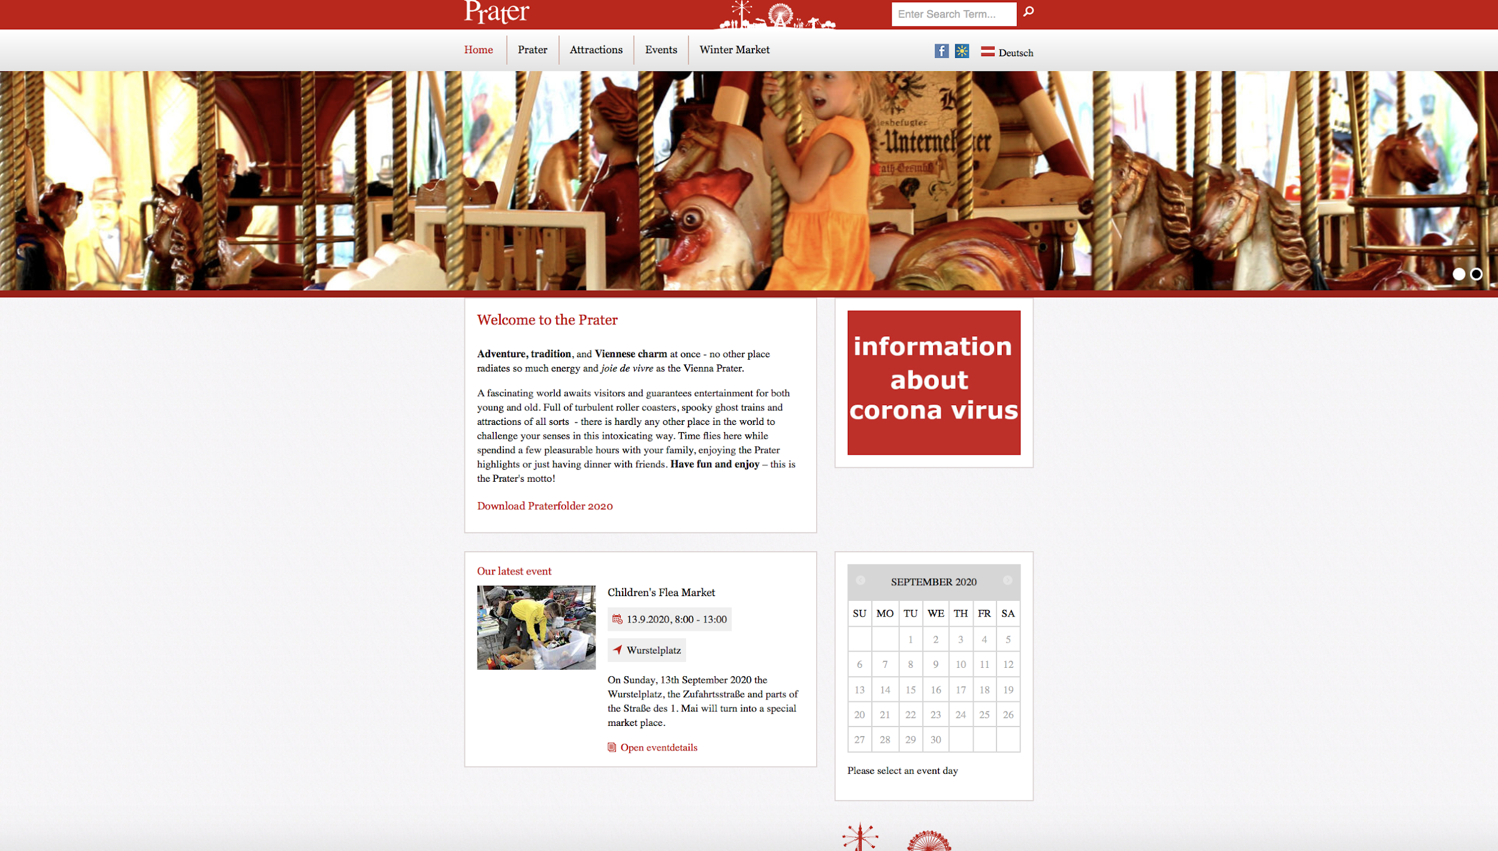

Good:

* English language option which shows that tourists are the main target audience
* Nice background
* Layout has a nice red/white contract befitting the theme of the Austrian flag
* Good and consistent color theme
* The menu selection is pretty clear
* Thoroughly lists attractions

Bad:

* The font is a bit outdated and hard to read.
* Text content seems to have been copy pasted from Word document
* The Winter Market menu option leads to a completely different website that opens a new browser
* Pictures are also a bit too large, especially the one with the kids
* Layout’s boxes/sections don't seem to align with one another, taking away from the aesthetics of the website
  + - for example: the boxes, the tabs, the search box, the flags: these are rectangles that look like they're randomly placed
  + News page has no visualization to break up monotony of text
  + Museum as an attraction listed on the news page looks boring because no visualization, despite being one of the attractions

Overall:

* Okay experience
* Outdated in terms of visualization, but very updated in terms of what's going on at the veue.

***Thorpe Park Resort (***[***https://www.thorpepark.com/***](https://www.thorpepark.com/)*)*

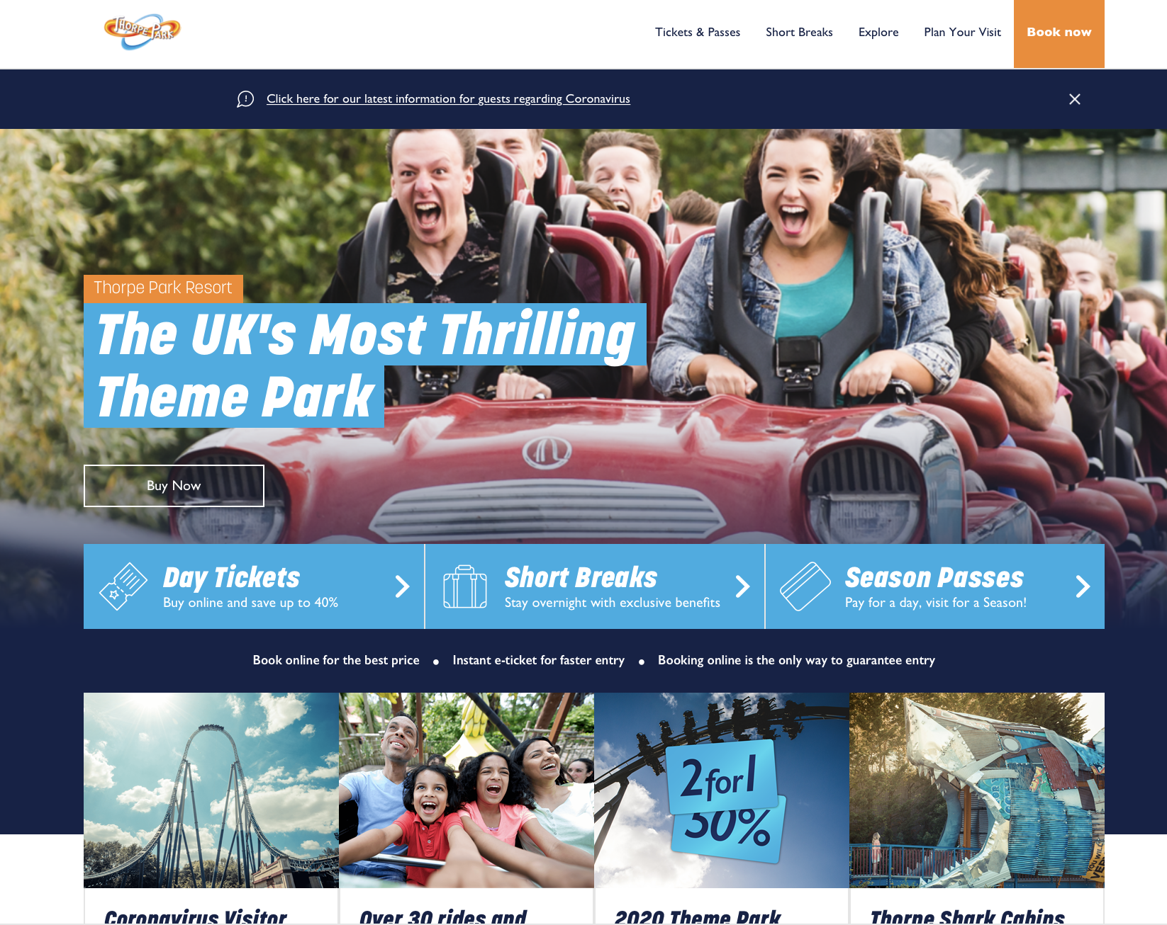

Good:

* Consistent blue color scheme
* Very visual, invokes excitement at first glance with one big picture
* Has a “plan your day option", which I find can helpful

Bad:

* Immediately greeted with a cookie message alert that makes one want to navigate away
* Another large message about Covid which comes across as too excessive
* Design / layout of the site is very clunky. Too many big pictures.
* Overall, the site just feels too cluttered. It's hard to get the information you want.
* Menu is not very clear and not what a user would expect.
* Upon clicking on the menu, you get more sub menus, which makes the navigation confusing
* Even when clicking on an important page, like Ticket Prices, you get even more pictures and you have to scroll down to get what you really want (ie the ticket prices).
* Too many 'Find Out More' text fields.
* Things that look like they should be hyperlinked aren't hyperlinked (“Book now", etc.)
* Intensely pressuring visitors to purchase tickets online (repeated texts in one spot saying “book online")
* Too much scrolling down needed for a home page

Overall:

* Not impressed. I was tempted to click away after a minute or so.
* Too visual, not enough information, and too much repeated information

*Europa Park (*[*https://www.europapark.de/en*](https://www.europapark.de/en)*)*

Good:

* The layout is cute. Maybe a bit too big, but it's still cute.
* Menu options are quite clear.
* Cookies alert is not annoying or in the way
* Second menu option that provides details about attractions, food/drink options etc.
* English language option that is of reasonably good quality
* Other language options though they are catered towards European ones
* Layout is nicely coordinated with the blue against white and friendly on the eyes.
* Very consistent color scheme
* Invites user interaction on home page, which is nice

Bad:

* A possible bad note might be the fact that home page has lots of options of exploration, which might be overwhelming (first line of tabs, second line of tabs, more options midpage)

Overall:

* Pretty good. One of the nicest sites I have seen so far!
* Very informative and looks professional without sacrificing the visuals.

***Oakwood Theme Park (***[***https://www.oakwoodthemepark.co.uk/***](https://www.oakwoodthemepark.co.uk/)***)***

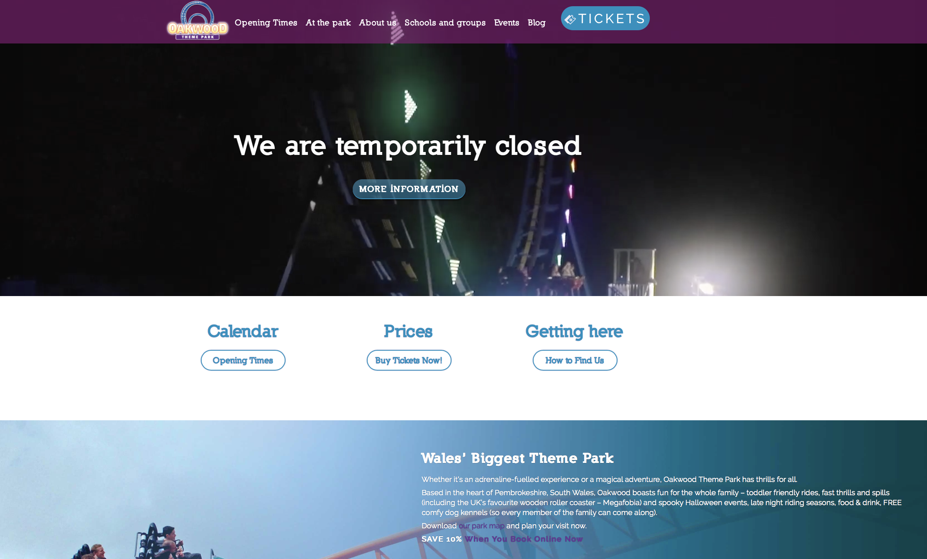

Bad:

* Flashy image on the home page - could be too much for some users who are prone to migraines and/or suffer from poor eyesight
* Color scheme is indinstinguishable
* Titles are cleared but presented poorly
  + - “opening times" are placed before “about us"
    - choices of capitalization/noncapitalization are poor
* The layout is not necessarily well coordinated since the font is hard to read (it is too bright and clashes with some of the darker elements on the page)
* The other pages continue that trend of fonts with bad colouring

Good:

* The menu is easily identifiable and information on how the site is structured is, thus, also easy to grasp
* Site knows who to target and that is evident in the menu since you can easily access information on how to book tickets as a school group, for example
* The fonts are big and there is not too much text on the site, which makes it easy to navigate for someone who wants to access the information right away
* The ticket link is placed on the top of the page, which is smart and makes it easy to purchase tickets.
* Address/contact are out of the way - hard to know where this park is located (other than in Wales)

Overall: Pretty decent, but it could be better.

***The London Resort (***[***https://londonresort.info/***](https://londonresort.info/)***)***

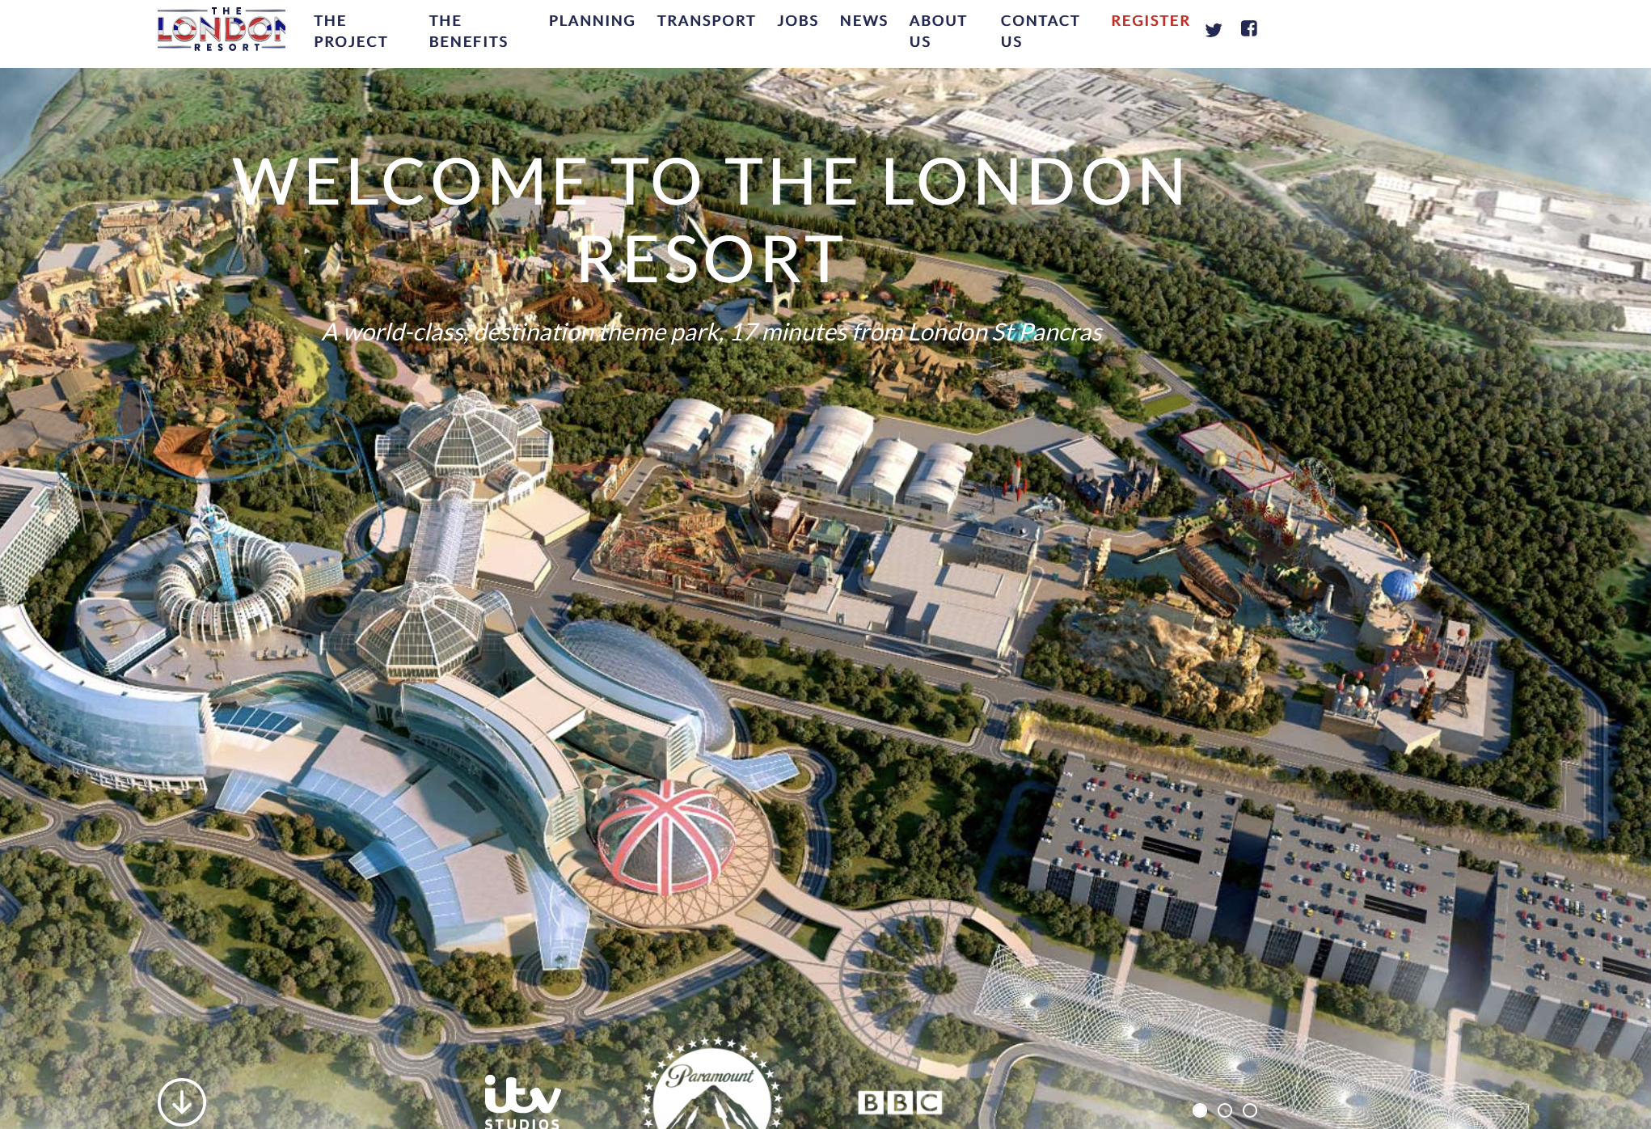

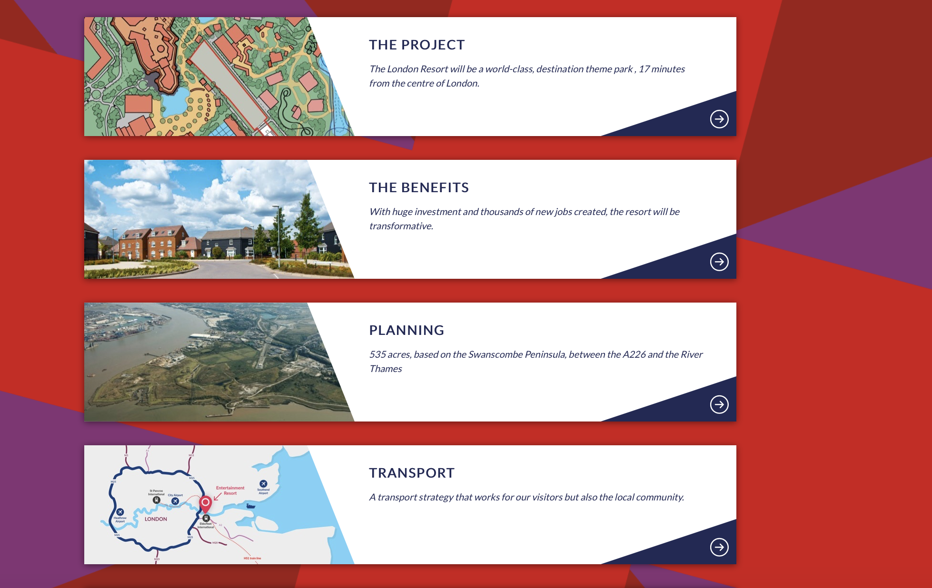

Bad:

* An alert about valuing the user’s privacy immediately pops up - it is large and very obtrusive.
* Texts fonts on the pages are sometimes a bit too bright or too big.
* Text almost unreadable on a cluttered background

Good:

* Well-structured layout that has some nice colour patterns
* The logo is well placed
* Clear menu that does not have you guessing where to find the relevant information about the theme park
* A very informative page that describes how this theme park will benefit a lot of people
* The layout seems very neat and modern, clearly having been designed by someone who knows a thing or two about web development

Overall: Pretty good.

**CONTENT:**

*Name of the theme park:* Cabin in the Woods; pun on the horror film ‘Cabin in the Woods’.

*Opening Times:* 24 hours, children allowed until 18:00

*Keywords:*

* Horror, Vampire, Halloween, Zombies, Night, Terror, Dark, Gothic
* Theme park in the woods

*Target audience:* Adults, teenagers, families with older children 8yo+

*Price range*: 5-15 euros per attraction

*Attraction-s (restricted by height or age):*

* Rides
* VR
* Haunted house
* Events (Halloween etc.)
* Specials (Rocky horror picture shows, parties - security id check - nighttime only)

*Amenities:*

* Medical aid available on-site
* Hotels
* Restaurants (horror themed, fast food and healthy vegan)
* Cafe

**Site structure**

*Logo + navigation:*

* Home/ Attractions / Amenities

*Attractions*

* Logo
* Event and ride highlights
* Prices
* About us
* Access information
* Attractions
* List of attractions with prices and age/height restriction, short description, picture
* Footer

*Amenities*

* Logo
* Food - List of available restaurants, short description of menu
* Hotel - List of available rooms and prices
* Footer